**Classroom Activity: Install Nodemon in your project and demonstrate its live reload functionality by making a small change in your server code.**

**Install Nodemon**:

npm install --save-dev nodemon

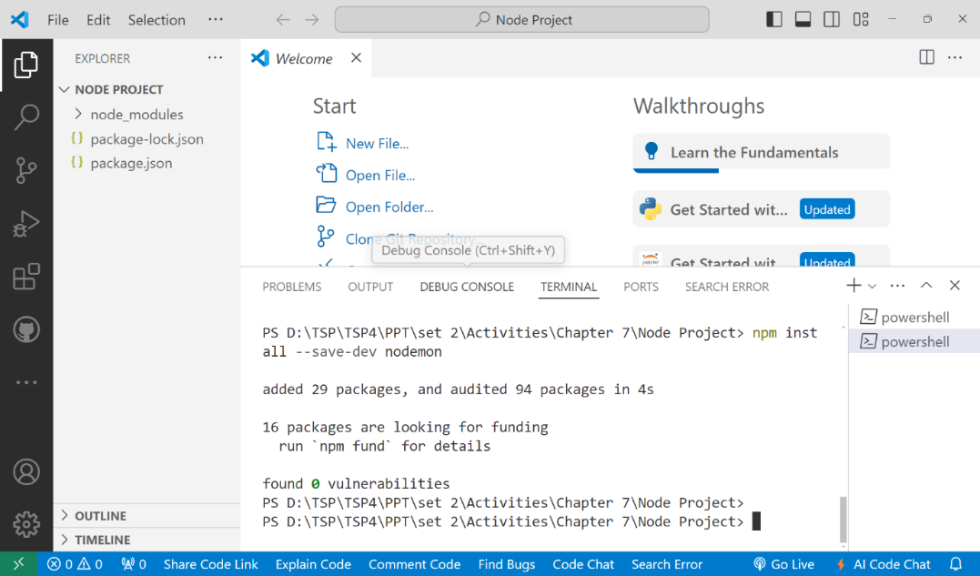

**Update package.json Scripts**: Add the dev script to your package.json to use Nodemon.

{

"scripts": {

"dev": "nodemon index.js",

"start": "node index.js"

}

}

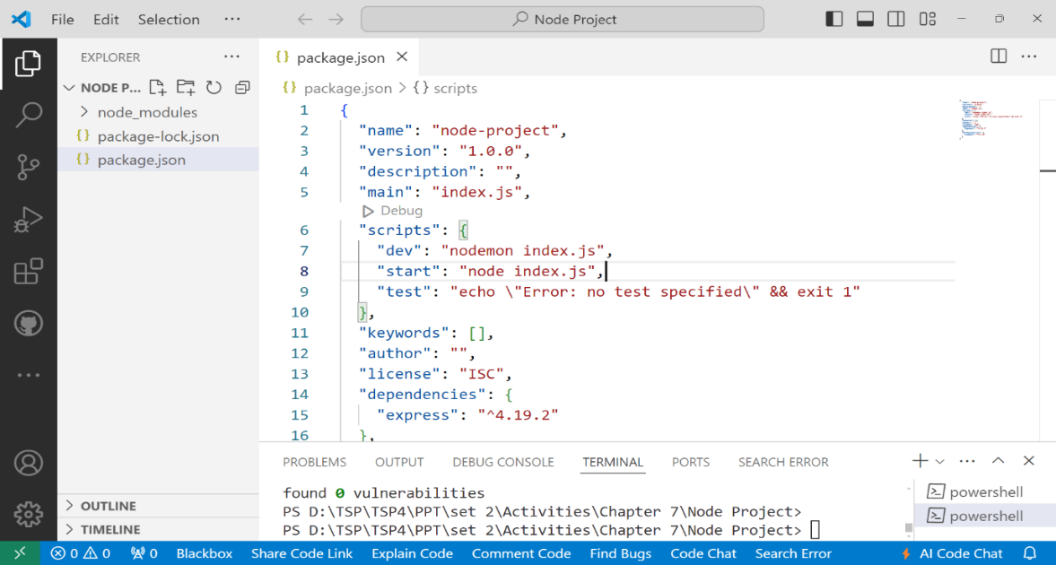

**Create index.js**: Create a basic Express server in index.js.

const express = require('express');

const app = express();

const port = 3000;

app.get('/', (req, res) => {

res.send('Hello World!');

});

app.listen(port, () => {

console.log(`Server is running on http://localhost:${port}`);

});

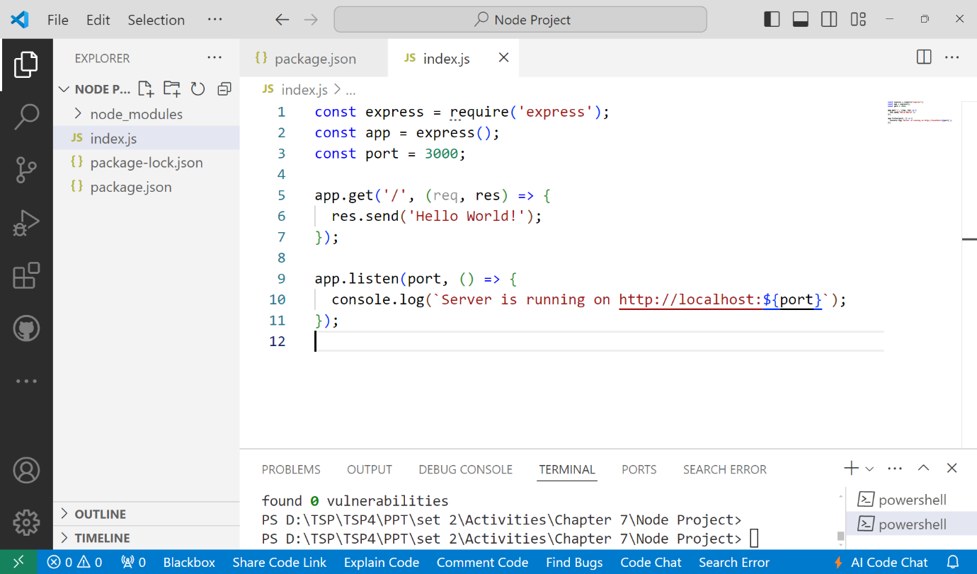

**Run the Server with Nodemon**: Start the server using the dev script to enable live reload.

npm run dev

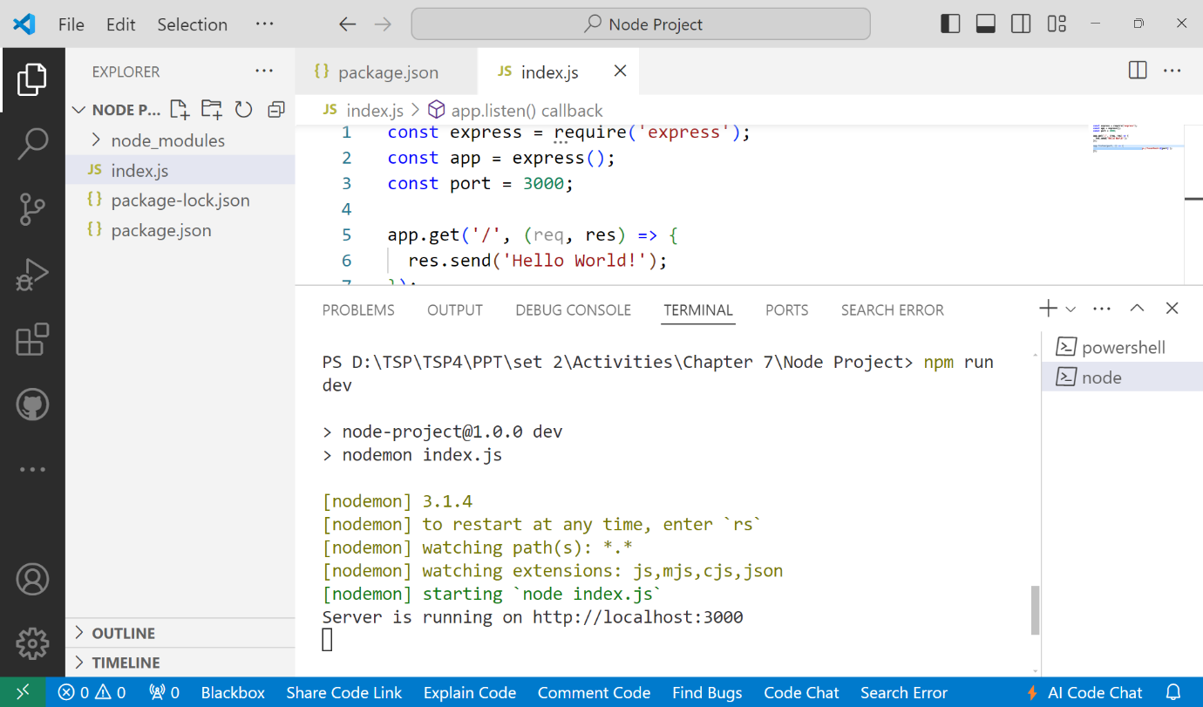

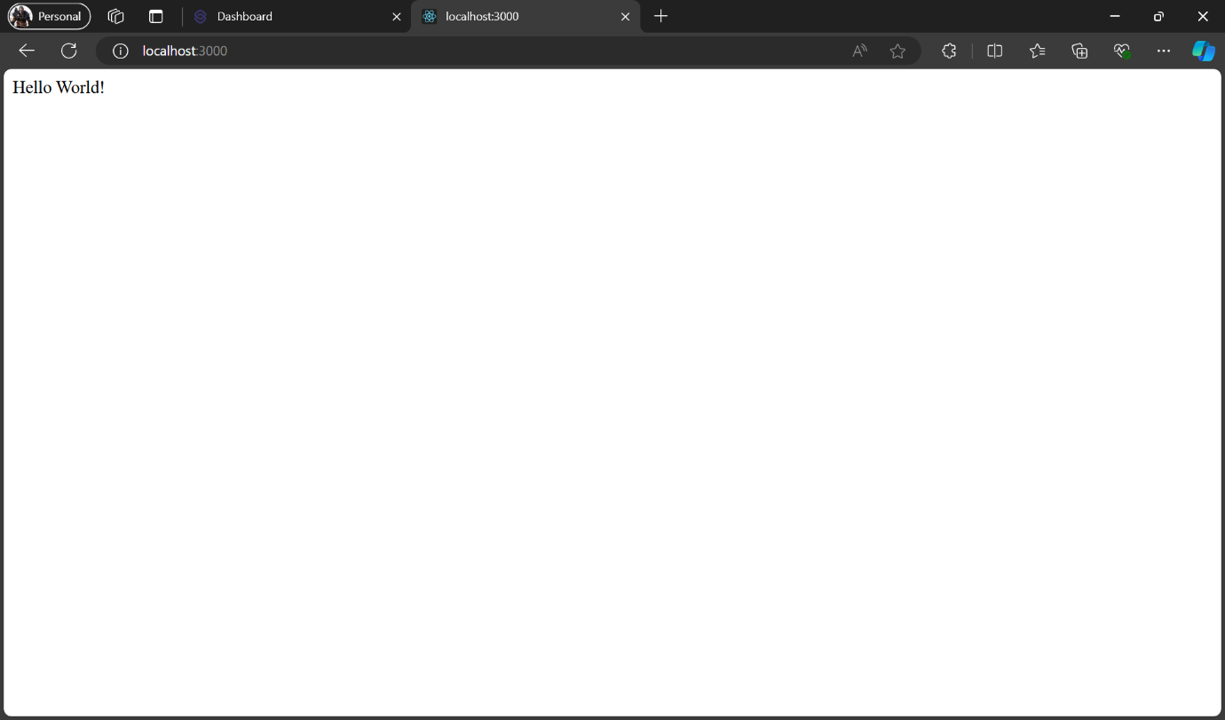

**Make a Small Change to Demonstrate Live Reload**: Modify the response message in index.js to demonstrate Nodemon's live reload functionality. Change:

res.send('Hello World!');

to:

res.send('Hello Nodemon!');

